Analysis of Electronidex Sales Transactions for Blackwell Electronics by James Sanders

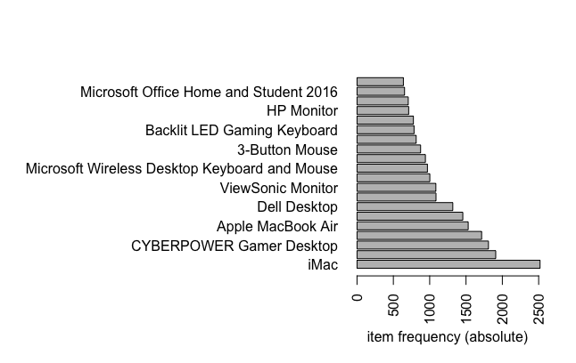An analysis was performed on sales transactions from Electronidex to see if Blackwell Electronics should purchase the company. 9835 sales transactions containing 125 different items from a 30 day period were analyzed. The most common items from the transactions are listed above.

While we cannot definitively say whether or not Blackwell Electronics should acquire Electronidex because we do not know the pricepoint at which these items were sold, or the profit margins from the sales we analyzed, we can say that there were some interesting patterns that were uncovered. The following are the top 3 associations we uncovered were reflected in .1 percent of the transactions but have a confidence level of 95%:

1. When a Dell KM117 Wireless Keyboard & Mouse were purchased along with a Iphone Charger Cable an Apple MacBook Air was over 6(6.12) times more likely to also be purchased that if the other two items were not in the transactions. This combination occurred in 20 transactions.
2. When an Asus Monitor, and Intel Desktop, and a ViewSonic Monitor were in a transaction a Lenovo Desktop was almost 7(6.75) times more likely to also be included in the transaction.
3. When an Acer Aspire, Koss Home Headphones, and A ViewSonic Monitor were in a basket an HP Laptop was more than 5 times more likely to be added into the transaction.

Based on these associations and the frequency of items in the transactions, it is recommended that Blackwell Electronics being carrying:

1)iMac based of frequency of this item in many transactions

2) ViewSonic Monitors because they often appear in transactions that are more likely to contain iMacs and are sold very frequently.

3)Dell Desktops because they often appear in transactions that are more likely to contain iMacs and are sold very frequently.

Below is the complete list of rules found in the analysis. .

